BACKGROUND SUBTRACTION
Ex No : 11
Date : 27/03/25

AIM :
To perform motion analysis by using background subtraction, averaging and detecting scene change methods.
FUNCTIONS :
- cv2.VideoCapture(video_path)
  - Opens a video file for processing.
  - video_path is the path to the video file.
- cap.isOpened()
  - Checks if the video file was opened successfully.
- cap.read()
  - Reads the next frame from the video.
  - Returns ret (boolean) and frame (image array).
  - If ret is False, it means the video has ended or an error occurred.
- cv2.imshow("Window Name", frame)
  - Displays an image or video frame in a named window.
- cv2.waitKey(25) & 0xFF == ord('q')
  - Waits for 25 milliseconds for a key press.
  - If 'q' is pressed, the loop exits.
- cv2.destroyAllWindows()
  - Closes all OpenCV windows.

Background Subtraction Functions
- cv2.createBackgroundSubtractorMOG2()
  - Creates a MOG2 background subtractor that adapts to changes in the scene.
- bg_subtractor.apply(frame)
  - Applies background subtraction to extract moving objects (foreground mask).
- cv2.GaussianBlur(fg_mask, (5, 5), 0)
  - Applies a Gaussian Blur to smooth the mask and reduce noise.

Scene Change & Motion Analysis
- cv2.accumulateWeighted(frame, avg_background, alpha)
  - Updates the background model using a running weighted average.
  - alpha controls how fast the background adapts.
- cv2.convertScaleAbs(avg_background)
  - Converts the floating-point background model into an 8-bit image for display.
- cv2.absdiff(frame, background)
  - Computes the absolute difference between the current frame and the estimated background.
  - Helps in detecting motion.
- cv2.cvtColor(frame, cv2.COLOR_BGR2GRAY)
  - Converts a color image to grayscale (useful for processing).
- cv2.threshold(gray_foreground, 50, 255, cv2.THRESH_BINARY)
  - Converts the grayscale motion mask into a binary mask (black & white).
  - Pixels above 50 intensity become white (255).
- np.sum(gray_foreground)
  - Computes the total intensity sum of the motion mask.
  - Helps detect scene changes when the sum is too high.
- cv2.putText(frame, text, position, font, size, color, thickness)
  - Draws text (e.g., "Scene Change: YES/NO") on the video frame.

ALGORITHM :
1️.Load & Display Video
- Open the video file using cv2.VideoCapture().
- Check if the file is opened successfully (cap.isOpened()).
- Loop through frames:
  - Read each frame using cap.read().
  - Display the frame using cv2.imshow().
  - Exit if 'q' is pressed (cv2.waitKey(25)).
- Release resources (cap.release(), cv2.destroyAllWindows()).
2️.Background Subtraction (MOG2)
- Initialize a Background Subtractor (cv2.createBackgroundSubtractorMOG2()).
- Loop through frames:
  - Read the current frame.
  - Apply background subtraction to get the foreground mask.
  - Smooth the mask using cv2.GaussianBlur().
  - Display the original frame and foreground mask.
  - Exit if 'q' is pressed.
- Release resources.

3️.Background Estimation using Averaging
- Read the first frame and initialize it as a floating-point background model.
- Loop through frames:
  - Compute running average background using cv2.accumulateWeighted().
  - Convert the floating-point background to 8-bit image (cv2.convertScaleAbs()).
  - Compute foreground mask (cv2.absdiff()).
  - Convert to grayscale and apply thresholding.
  - Display the original frame, estimated background, and foreground mask.
  - Exit if 'q' is pressed.
- Release resources.
4️.Scene Change Detection
- Read the first frame and initialize background.
- Define learning rate (alpha) and scene change threshold.
- Loop through frames:
  - Update the background model using cv2.accumulateWeighted().
  - Compute the foreground mask (cv2.absdiff()).
  - Convert to grayscale.
  - Compute the sum of pixel intensities to measure total motion.
  - Compare with threshold to detect scene change.
  - Display scene change status (cv2.putText()).
  - Display frames and masks.
  - Print log if a scene change is detected.
  - Exit if 'q' is pressed.
- Release resources.
CODE SNIPPET :
import cv2

video_path = r"C:\Users\subha\Downloads\ROAD.mp4"
cap = cv2.VideoCapture(video_path)

if not cap.isOpened():
print("Error: Could not open video.")
exit()

while True:
ret, frame = cap.read()

if not ret:
print("End of video or error.")
break

cv2.imshow("Video Frame", frame)

if cv2.waitKey(25) & 0xFF == ord('q'):
break

cap.release()
cv2.destroyAllWindows()

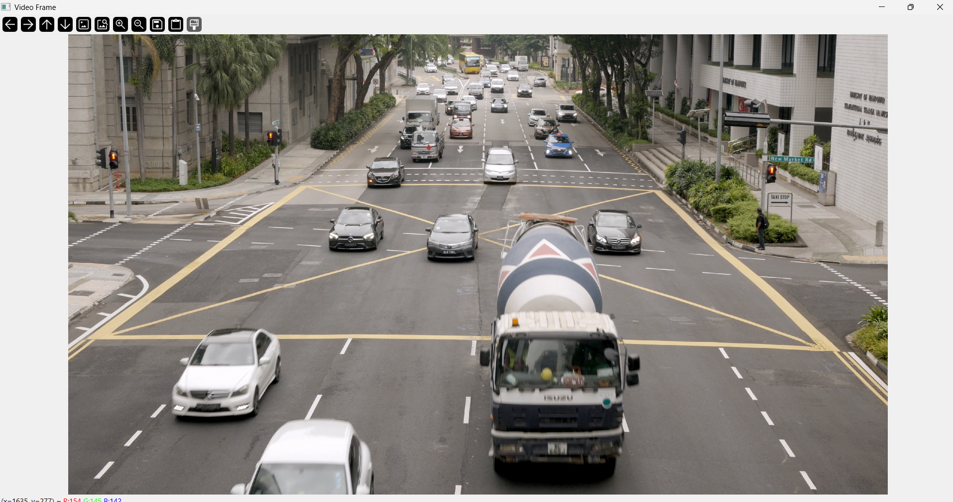

# Background Subtraction :

import cv2

video_path = r"C:\Users\subha\Downloads\ROAD.mp4"
cap = cv2.VideoCapture(video_path)

if not cap.isOpened():
print("Error: Could not open video.")
exit()

bg_subtractor = cv2.createBackgroundSubtractorMOG2()

while True:
ret, frame = cap.read()

if not ret:
break

fg_mask = bg_subtractor.apply(frame)

fg_mask = cv2.GaussianBlur(fg_mask, (5, 5), 0)

cv2.imshow("Original Video", frame)
cv2.imshow("Foreground Mask", fg_mask)

if cv2.waitKey(25) & 0xFF == ord('q'):
break

cap.release()
cv2.destroyAllWindows()

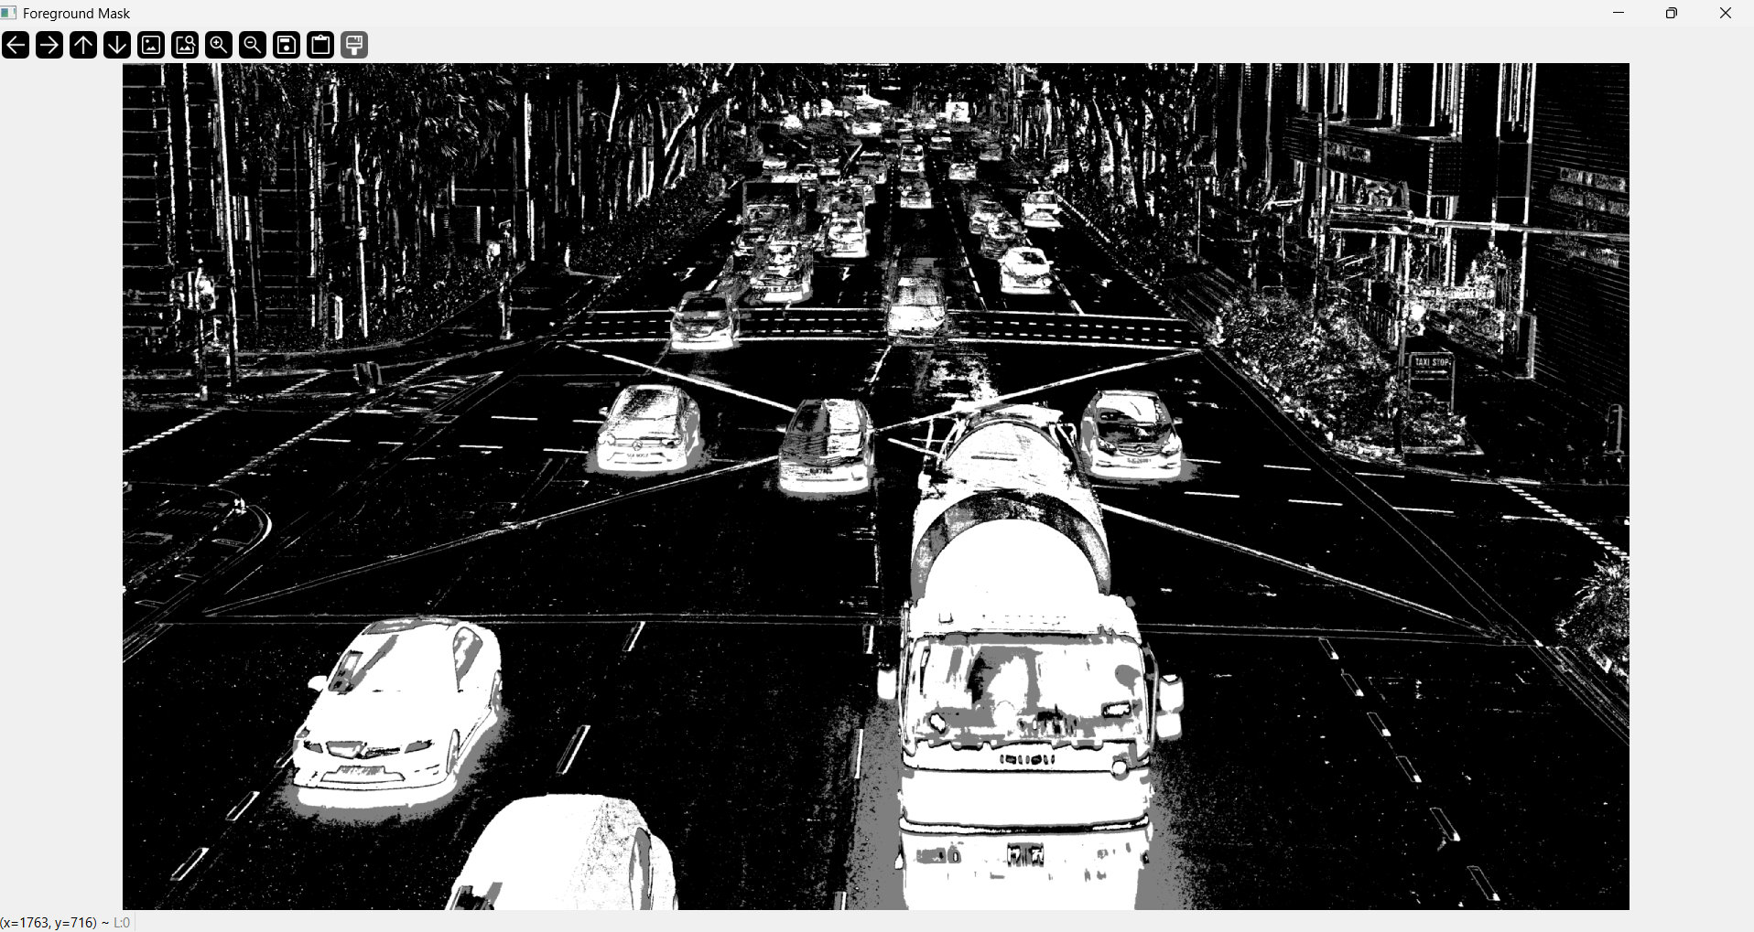

# Averaging :

import cv2
import numpy as np

video_path = r"C:\Users\subha\Downloads\ROAD.mp4"
cap = cv2.VideoCapture(video_path)

if not cap.isOpened():
print("Error: Could not open video.")
exit()

ret, frame = cap.read()
if not ret:
print("Error: Could not read the first frame.")
cap.release()
exit()

avg_background = np.float32(frame)

alpha = 0.02

while True:
ret, frame = cap.read()
if not ret:
break

cv2.accumulateWeighted(frame, avg_background, alpha)
background = cv2.convertScaleAbs(avg_background)

foreground_mask = cv2.absdiff(frame, background)

gray_foreground = cv2.cvtColor(foreground_mask, cv2.COLOR_BGR2GRAY)
_, binary_mask = cv2.threshold(gray_foreground, 50, 255, cv2.THRESH_BINARY)

cv2.imshow("Original Frame", frame)
cv2.imshow("Estimated Background", background)
cv2.imshow("Foreground Mask", binary_mask)

if cv2.waitKey(25) & 0xFF == ord('q'):
break

cap.release()
cv2.destroyAllWindows()

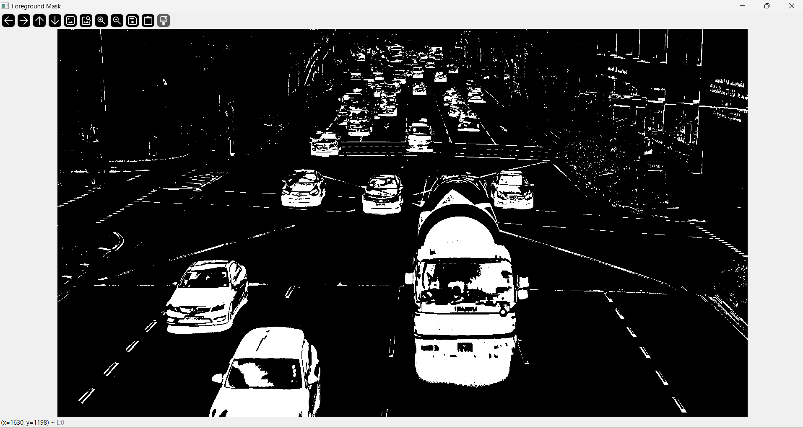

# Detect Scene change :

import cv2
import numpy as np

video_path = r"C:\Users\subha\Downloads\ROAD.mp4"
cap = cv2.VideoCapture(video_path)

if not cap.isOpened():
print("Error: Could not open video.")
exit()

ret, frame = cap.read()
if not ret:
print("Error: Could not read the first frame.")
cap.release()
exit()

avg_background = np.float32(frame)

alpha = 0.02 # Learning rate for background update
scene_change_threshold = 3000000

while True:
ret, frame = cap.read()
if not ret:
break

cv2.accumulateWeighted(frame, avg_background, alpha)
background = cv2.convertScaleAbs(avg_background)

foreground_mask = cv2.absdiff(frame, background)

gray_foreground = cv2.cvtColor(foreground_mask, cv2.COLOR_BGR2GRAY)

scene_change_score = np.sum(gray_foreground)

scene_change_detected = scene_change_score > scene_change_threshold

status_text = "Scene Change: YES" if scene_change_detected else "Scene Change: NO"
cv2.putText(frame, status_text, (20, 50), cv2.FONT_HERSHEY_SIMPLEX, 1, (0, 0, 255) if scene_change_detected else (0, 255, 0), 2)

cv2.imshow("Original Frame", frame)
cv2.imshow("Estimated Background", background)
cv2.imshow("Foreground Mask", gray_foreground)

if scene_change_detected:
print("Scene Change Detected!")

if cv2.waitKey(25) & 0xFF == ord('q'):
break

cap.release()
cv2.destroyAllWindows()

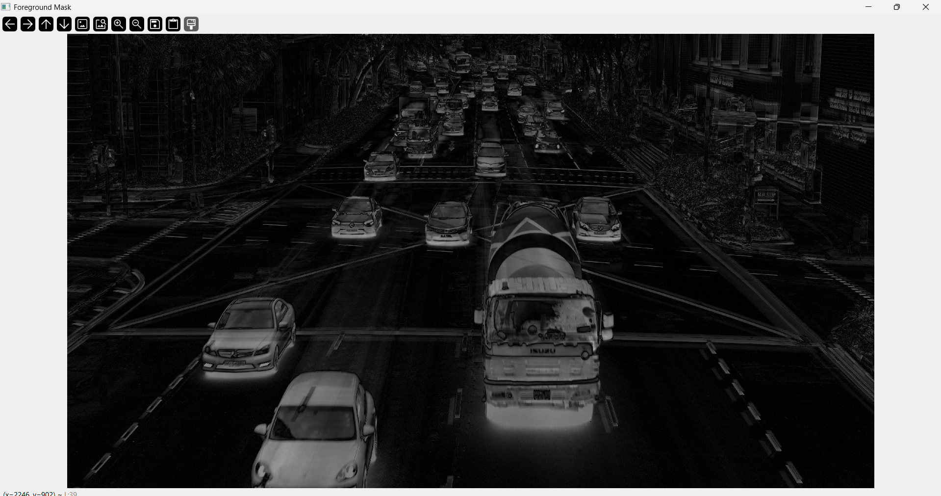

RESULT :
Thus, motion analysis using background subtraction, averaging and detect scene change was performed successfully.

